**Retail Sales Analysis — Key Findings & Insights**

**1. Data Cleaning & Preparation**

* **Date Standardization**: Order_Date successfully converted to datetime format, enabling time-based analysis.
* **Numeric Data Fixes**: Columns like Quantity, Price, Total_Sales, and Customer_Age were coerced into numeric format; missing values were replaced with **median values**, reducing data gaps while minimizing distortion.
* **Categorical Fixes**: Missing values in Payment_Method, Gender, Product_Category, and City were filled with "Unknown", ensuring group-based aggregations worked correctly.
* **New Features**:
  + **Order_Month**: Extracted to track monthly trends.
  + **Age_Group**: Binned into categories (<25, 25-34, 35-44, 45-54, 55+) for demographic analysis.

**2. Revenue by Product Category**

* Categories contribute unequally to revenue — a few **top categories dominate total sales**, while others generate minimal income.
* This indicates potential for **product focus strategy**, where top categories could be marketed more aggressively, while low-performing ones could be evaluated for discontinuation or repositioning.

**3. Monthly Sales Trend**

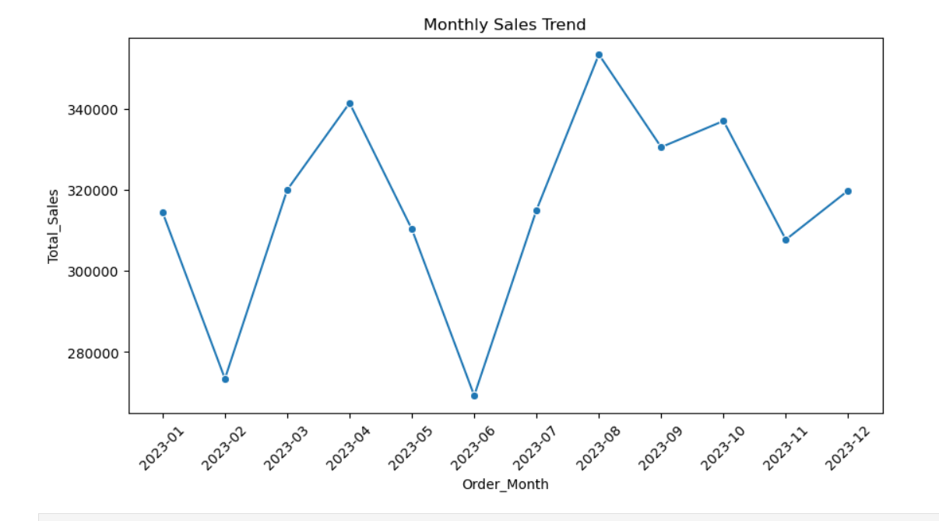

* Clear **seasonality** observed — certain months show noticeable spikes in revenue.
* Possible causes: **festive seasons, promotions, or product launches**.
* Recommendation: Align **inventory and marketing spend** with these peak months to maximize sales impact.

**4. Customer Demographics**

**Gender-based Insights**

* **Male customers** contributed more revenue than females, though both are significant.
* Marketing strategies could **balance gender targeting** — e.g., offer male-preferred product bundles, but also run campaigns to increase female customer engagement.

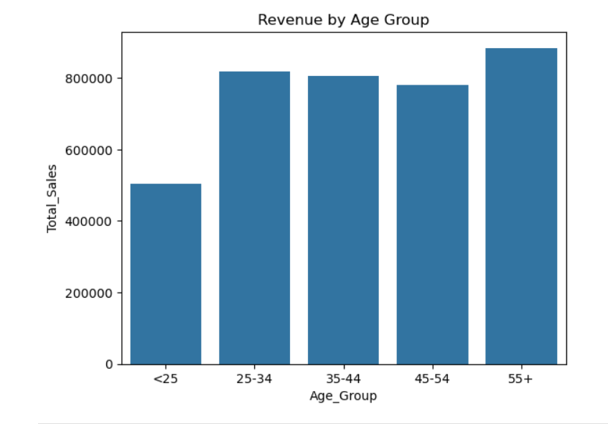

**Age Group Spending**

* The **25–34** and **35–44** segments spent the most — indicating they are the **core revenue drivers**.
* Customers **<25** and **55+** spent significantly less — suggesting lower purchasing power or different product preferences.
* Targeted offers for young professionals (25–34) could boost overall revenue further.

**5. Top Products**

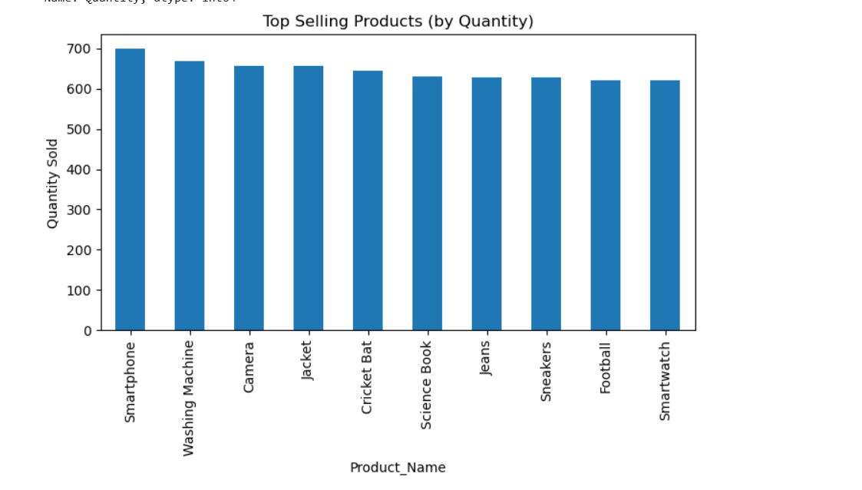

* Certain SKUs consistently appear in **top revenue contributors** — these should be prioritized for:
  + **Stock availability**
  + **Upselling & bundling**
  + **Premium positioning** (if price elasticity allows)

**6. Actionable Recommendations**

1. **Double down on high-performing categories** while reassessing low performers.
2. **Synchronize marketing campaigns** with high-sales months.
3. Increase **engagement with the 25–44 age group**, as they drive most of the spending.
4. Explore strategies to **capture underperforming age segments** via discounts, smaller packs, or trendy product lines.
5. Maintain **inventory resilience** for top products to prevent lost sales.